Updated Tender Israel Police
HQ /Logistic Support Department
Purchases and Sales Department
Baalai Hamelacha 41
the industrial area of Ramla
phone : 08-9124228 Fax- 09-7697832
November 19 th 2014

Re: Notice of publication of the Public Tender No. 42/2014
subject: selling ship type "Hercules "

1. General :
1.1 The Israeli Police is interested in selling a boat of the type " Hercules" (hereinafter : " the goods) As specified in the tender documents and specifications in all its appendices , in light of this you are invited to participate in the tender in sentenced.
1.2 The tender documents will be given upon presentation of a receipt to the Israel Police, in the Department purchases and sales which is located at Baalai Hamelacha 41 the industrial area of Ramla.

2. Prior conditions for participation in the tender.
2.1 Attach a bank check to the order of the Israeli Police sum of 50,000 NIS and / or 10,000 euro's or $ 13,000 as a collateral for this tender.
2.2 Failure to Attach a bank check would lead to disqualification of the bid.

3. Deadline for proposals: 6th of January 2015 2:00 pm
3.1 Proposals will be submitted to the appropriate tender box at the Secretary office, Department purchases which is located at HQ Ramla, Baalai Hamelacha 41.
3.2 On the envelope , Wright the subject and the number of the tender.
3.3 Do not send the offer by mail /fax , but to place it personally in the tender box until the deadline for submission of proposals.

4. Tender participation fee
Tender participation fee of 800 NIS (non-refundable) will be done by one of the following options:
A. With a credit card on the website of Government Purchasing at www.mr.gov.il After entering the auction link. It is hereby clarified that any objection by the bidder on the inability of paying the Participation fee close to the deadline, due to some technical problem on the website will not be acceptable . Therefore, it is recommended for bidders to make the payment earlier.
B. Participation fee by postal bank account , which its number is number 025106-7 ,stating the number of the tender. Copy of payment voucher must be delivered to the sales and purchases department of the Israel Police by fax 09-7697836 or email mirish@police.gov.il indicating the tender number, company name / bidder, address, H.f or VAT registration number, contact name, telephone number, fax number and email address.
C. Keep the online payment authorization and / or bank payment authorization and attach their copy to the proposal as detailed in the tender documents.
D. For the avoidance of doubt, the authoritative wording is the version delivered to participants in the department of purchases or the version from the website (including changes or updates that may occur and will be given to those who purchased the tender documents). The tender should be submitted only on the tender documents that where purchased legally .
5. For further information, please contact the editor of the tender - Chief Inspector Oren Abraham phone 08-9124228 on days Sunday-Thursday between the hours of 8:00-4 :00 (except Friday, the eve of holidays, and festivals) or fax 09 -7,697,832 and email: orena@police.gov.il

Best Regards ,
Shaul Cohen , Commander
Head of Department Purchases and Sales
And Chairman of the Tender Committee

Updated tender Israel Police
HQ /Logistic Support Department
Purchases and Sales Department
Baalai Hamelacha 41
the industrial area of Ramla
phone : 08-9124228 Fax- 09-7697832
November 19 th 2014
Public Tender No. 42/2014.
Topic: Selling boat
1. General
1.1 With the authority of the Israeli Police , Marine Police, a boat of the kind "Hercules" which is up for sale according to the tender conditions and specifications hereinafter.
1.2 You are invited to participate in this tender, the tender documents can be received for a fee of 800 NIS (Non-refundable), which need to be deposited at the postal bank ,account number 025106-7 stating the tender number.
1.3 The tender documents will be handed over to the participant or the bidder upon presentation of a receipt at the Israeli Police, Purchases and sales Department , Ramla, Baalai Hamelacha 41.
1.4 Engineer report will be handed to the bidders who are interested by the editor of the tender .
1.5 For further information, please contact the editor of the tender - Chief Inspector Oren Abraham phone 08-9124228 on days Sunday-Thursday between the hours of 8:00-4 :00
2. Deadline for proposals: 6th of January 2015 2:00 pm
3. . Prior conditions for participation in the tender.
3.1 Attach a bank check to the order of the Israeli Police sum of 50,000 NIS and / or 10,000 euro's or $ 13,000 as a collateral for this tender.
3.2 Failure to Attach a bank check would lead to disqualification of the bid.
4. Submitting a bid in the tender
4.1 The bidder must fill out the attached bid: Appendix B (hereinafter - "the bid ") sign it and transfer it together with the attached bank check sum 50,000 NIS and / or 10,000 euro's or $ 13,000 in a sealed envelope, with no identifying information of the bidder , attached with all the other tender supplements and the required approvals according to the tender , completed and signed, to the appropriate tender box at the Secretary's office Purchases Department located at HQ Ramla, Baalai Hamelacha 41. On the Envelope write the topic and the tender number.
4.2 The published price in the quotation will be final and permanent.
It is hereby emphasized that The Israeli Police does not issue tax invoices and that the best of our knowledge, there is no possibility to offset tax from this deal.
4.3 The price offered for the boat in the quoting form will include all direct and indirect costs Involved. Including insurance, transportation, security, taxes, levies, registration and so on.
4.4 Do not send the offer by mail /fax , but to place it personally in the tender box until the deadline for submission of proposals.
4.5 The Bidder will attach on the outside of the envelope (or package) another envelope, tightly closed. Without the bidder details on its back, and inside will appear the name of the bidder and a contact person on his behalf . (name , phone number and address ) for restoring the proposal if necessary.
4.5 Objections: It is hereby emphasized that you can't stipulate the bid under any circumstances, likewise, there is no possibility to Make any changes in the formulation of the tender documents submitted by the police, do not write any stipulation regarding the requirements specification documents, or add an addition in the body of the document or accompanying a letter or otherwise. Such stipulations may result in disqualification of the Proposal. Bidders interested to express any stipulations and / or make a change in the tender documents , will write his request down and give it to the police representative as described in Section 15.
4.6 If the bidder assumes that there is a defect in the tender documents and / or impairment and / or lack of clarity and / or missing mandatory, he must inform the police representative in writing in accordance with section 15 hereinafter .If he has not done so, This will be considered as a concession of any damage or expense that will be caused or may be caused to the bidder As a result he would not be entitled to prosecute or to demand indemnification from the Customer, whether he won the tender or he didn't win.
5. Here are instructions for the submission of the bank check:
5.1 The bank check attached to the proposal must be the original bank check . (Photo / copy will not be accepted).
5.2 The check needs to be for the Israeli Police .
5.3 The bank check will be returned to the bidders ( except the winner ) after making the decision regarding the winner.
All the permanent conditions concerning the bank check, among them: attaching the original bank check , Unconditional and non-negotiable, etc.- These are essential terms and deviation from them will result in disqualification of the bid.

6. Documents and approvals that need to be attached to the proposal
6.1 Appendix A - Liabilities and declarations of the bidder
6.2 Appendix B -Quote document .
6.3 The original bank check as mentioned in section 3.1.
6.4 Appendix C - Bank account credit form attached, completed and signed by the bank or by an accountant.

6.5 If the bidder is a business where the controlling owner is a woman, as provided in section 2B, of the Mandatory Tenders Law, (Hebrew year) - 1992, and he wants to get preference under this law - attach an approval form from an accountant and her declaration as required by the law mentioned above.
6.6 despite the obligation to attach all approvals and documents to the proposal , the tender committee may allow the bidder to complete his production except appendix B (the quote form) and the bank check in the time period which will be determined and this is as long as the approvals and or documents are clear which are mentioned above that where existent and valid on the date of submission of the proposal as required by the terms of the tender.
6.7 All the appendixes that their formulation is attached shall be submitted without any changes and according to the formulation of the appendix.
7. The method of determining the winner and an alternative winner
The winner will be determined the following way.
7.1 The Proposals will be graded from low to high according to the amounts of proposals submitted.
7.2 The Proposals will be considered according to the exchange rate of the dollar / euro on the deadline for submitting bids.
7.3 If the gap between the first proposal and the proposal ranked second will be 10 % or more, the police may ,but no required, to make a competition between the three proposals ranked first.
7.4 In this case the police will refer to the bidders as mentioned above with a request that the bidders submit an improved tender offer. The bidders will be required to submit an improved tender quote offer by the date to be determined .
7.5 The improved offer will have to be submitted by the bidders in the appropriate tender box , which will open in the Purchases Department of the Israeli Police, Ramla, Baalai Hamelacha 41st.
7.6 A bidder that decides not to submit an improved offer ,his offer will be considered as the proposal he submitted to the tender.
7.7 There is no possibility to provide a lower bid then the first offer, in any case the higher offer will be the one considered.
7.8 After submitting the improved offers according to the date that will be determined , the proposals will be ranked again. The proposal ranked at first place which meets the threshold conditions will determinate the winner.
8. Estimate:
There is an estimate in this tender. It is hereby clarified that the Tenders Committee, ,according to their consideration, reserve the right to reject proposals that are deviated downward 25% from the estimation and in certain circumstances at the exclusive consideration of the Tender Committee also can cancel all or part of the tender. The mentioned above does not affect the authority of the Tender Committee to act upon the Mandatory Tenders Regulations and especially the mentioned in Article 21 (A1).

9. Payment terms:
9.1 Within 10 days of receiving the winning notification in writing by the winner, the winner will transfer a bank transfer of all of the exchange for the boat to a bank account that he will receive in the winning message.
9.2 Upon presentation of the bank approval to make the deposit and approval consent of the Accounting Israeli police that the exchange was deposited in the bank account mentioned above, the bank check will be returned to the winner as mentioned in section 3.1 in the tender.
10. Prior tests
For early tour inspection on the boats outside condition and technical privatization will only be possible on land.
10.1 To coordinate a time to examine the boat out of the water at the base Atarot of the Israeli Police ,Contact by fax No. 09-7697832 ,Chief Inspector Oren Abraham until Monday 11/30/2014
Delivery of the goods:
Hereinafter a schedule for implementation:
10.2 The payment to the Israeli Police will be within 10 days from the day of the winning notification
10.3 The winning bidder will be required to sign a sales agreement attached to the tender.
10.4 The boat will be delivered to the winner against presentation of a confirmation of payment by the Finance Unit and / or from the accounts department in the amount of winning sum .
10.5 The winning bidder will be responsible for the bear and cost of licensing the boat if in Israel or any other country.
10.6 If the winner has already paid but did not take the boat, the police will not be responsible for Damages that may occur to boat from the date that he was supposed to take the boat from the polices warehouses and until the actual removal .
11. General conditions to perform this tender:
11.1 Handling, transporting and packaging, etc. are applied on the winner ,at his expense and responsibility .
11.2 There is no possibility to make changes to the boat before purchasing ,including activities of disassembly and assembly and any work on the boat at the Police base.
11.3 The winner will be requested to sign the attached agreement.
12. Fundamental fines and violations : in accordance with Section 7 to the attached agreement.
13. Ownership of the tender and bid
13.1 This tender is intellectual property of the police that is transmitted to provide for submitting a proposal only. Do not use it for any purpose except preparing the proposal.
13.2 The bidder's bid shall be considered given without any trade secret or professional secret and the bidder is aware that if he is determined the winner, his proposal will be reviewed by participants in the tender.

13.3 If the bidder wanted to prevent browsing in certain parts of his proposal because of trade secret or professional secret , then he needs to indicate on a separate piece of paper the parts in the proposal , giving reasons for claim that they are professional secrets . The final decision regarding the prevention of parts from his winning proposal because of trade secret or professional secret in any case the decision is given to the discretion of the Tender Committee.
13.4 It is emphasized that the bidder that requested a matter and / or part of his bid to be considered a trade secret or professional secret, will be prevented from browsing in the same subject and / or the relevant part of a proposal that appear in the other bidders proposals , regardless of the decision of the tender committee if to keep a secret or not .
13.5 In any case the bid price shall not be considered a trade secret or a professional secret.
13.6 The tender committee will not consider a request to prevent the browsing in a proposal claiming trade secret or professional secret, if it is not explained and / or a comprehensive sign in the proposal .

14. Questions and clarifications
14.1 If the bidder will find contradictions, errors, inconsistencies etc. in the tender documents and in front of any law, regulation , or had any doubt regarding the exact meaning of section or any information in connection with the tender and the engagement , shall notify in writing to the tender editor as close as possible to the date of publication of the tender.
14.2 The request shall include the name of the tender, the tender section number that refers to the question, details of the question, details of the asker, phone number, fax number and email address.
14.3 Clarifying questions can be transferred in writing until: 12/25/2014 at 12:00.Fax 09-7697832. You can verify the arrival of fax or mail by phone No. 08-9124228.
14.4 Clarification questions will not be accepted after this date.
14.5 The answers to the clarification questions will be sent by fax to all the bidders without the mention of the name of the applicant.
14.6 For the avoidance of doubt, it is clarified and emphasized that the exclusive determinant terms of the tender will be the conditions set out in writing and not given orally to change or to add on them.

Shaul Cohen , Commander
Head of Department Purchases and Sales
And Chairman of the Tender Committee

Appendix A to the tender 42/2014
Commitments and declarations of the bidder to the tender number 42/2014
A. I declare that I am authorized to sign on behalf of the bidder on this Appendix and the other supplements to tender on behalf of the corporation and its directors and read the tender documents and its appendices. I agree with all of the terms set forth and hereby submitting the proposal of the bidder.
B. I pledge that if it would require me, within 15 days from the day I'm determined winner, to sign an agreement / order, according to the terms of the tender and according to my proposal as detailed , I will sign the agreement / order as stated.
C. I am aware that violation of my obligations shall entitle the police an agreed compensation, as specified in section 3 in the tender. May (if required) to collect the collateral I have gave to secure my obligation .
D. I hereby agree that a qualified factor in the police will review the full relevant information from the crime register and intelligence as mentioned in the criminal records law and rehabilitation . I am aware that failure to give the agreement as required above disqualifies my proposal.
E. I am aware that the bidder must obtain authorization of field security as a condition for receiving the proposal and that In this context will be considered all of the criminal information and intelligence as far as exists.
F. I am aware that every employee on behalf of the bidder must have a prior written approval of field security unit of the police, as a condition of his employment by the bidder providing service bears this request.
Declaration regarding the non-coordinating tender
A. The prices that appear in my bid were determined by my company independently, without consultation or arrangement or contact with another bidder or contact with a potential bidder.
B. The prices contained in this proposal were not disclosed to any person or corporation that offers in this tender or corporation that has the potential to bid in this tender.
C. I was not involved in an attempt to dissuade another competitor from offering bids in this tender, or cause another competitor to bid higher or lower than my offer.
D. The bid is given in good faith and not as a result of an arrangement or an argument or a forbidden negotiation with a competitor or a different potential competitor in this tender.
Date | ____ / ____ / ____
Company name/bidder
No. licensed dealer
Police company number (if available)
Contact person number
Phone number
Cell phone number
Fax number
town
street
House number
Zip code
Mailbox (if any):
Signature and stamp

Appendix B

Quote -for tender 42/2014

Item Name | Price in NIS / $ / EUR
Boat

Comments:

1. The boat will be given to the winner in its current condition AS IS .
2. Proposals will be considered according to the exchange rate of the dollar / euro on the deadline for submitting bids.

______________ ___________________ ________________
Date Contact person The bidder

Appendix C to the tender

In honor of the
Israeli police / national headquarters
Accounting / Department of Finance / Treasury / suppliers
Jerusalem -91906
Re: - Payment to the beneficiary through crediting bank account
A. We hereby your request to make payments for the goods / services we provide / will provide for you, by crediting our bank account as follows:
Name of supplier |  |  | No. licensed dealer / ID / non-profit organization

Bank Name |  |  |  |  |  |  |  |  |  | bank symbol
Name of branch |  |  |  |  | Branch symbol
Bank address |  |  | Account Number

B. Any changes in the specifications in Section 1 above, we will inform as soon as possible - in writing signed by an authorized signature and the businesses stamp .
C. Facsimile number to which you can transfer details of the payments that were transferred to our account, if the facsimile number will be changed we will update you as soon as possible.
Area code |  |  | Telephone NO. |  |  |  |  |  |  |  | Area code |  |  | Fax NO.

D. If the Israel Police would do everything that a reasonable person would have to do to credit his bank account based on the information provided by us, we shall have no claim or prosecution of any kind for non-payment.
E. This form does not serve as a check to receive credit and not a commitment to purchase equipment / services and / or make a payment.
F. The Israeli Police payment according to the details provided by us, this letter will be considered as full payment.
G. We will not have any claim against the Israeli police for non-payment if we didn't give full details or inaccurate details prescribed by this letter
_______________ __________________________________________
Date Signature of authorized signer and business stamp
I approve that the information above match the company /business
_______________________ ___________________________________
Date Bank signature / Accountant

Appendix D to the tender

Re: A declaration of bankruptcy and no claims for Tender No. 42/2014

I the undersigned __________ I.D ____________ Having been warned that I must tell the truth and that I will be subject to punishment under the law if I do not do so, I declare as follows:
1. I am giving this declaration on behalf of _________________ That he is the body wishing to connect with the client in the tender framework (hereinafter "the bidder"). I serve as _______________ I am a certified to give this declaration on behalf of the bidder.
2. I hereby declare that as this declaration day_____________ No conducted lawsuits against the bidder that may adversely affect the extent that he wins the tender and that is not in proceedings of bankruptcy and / or dismantling that may adversely affect the extent that he wins the tender.
3. This is my name hereinafter my signature and the content of my declaration is true.

____
The Bidder

Authorization
I the undersigned ________________ Attorney, approve that on day ___________ appeared before me in my office on street _______________ in town ________________ Mr./Ms. _______________ that Identified himself/herself with an I.D _______________ that is known to me personally, and after I warned that he needs to declare the truth and that he will be subjected to punishment under the law if you won't do so , sign before me on this declaration above.

_______________________ __________________________________ ________ Attorney/lawyer signature stamp and license number of the attorney Date

An agreement to sell boat
Between: Israeli police on behalf of Israel by the ______________________________ and ______________________________ (hereinafter "the police")
and between : ______________________________ (hereinafter "the company") by its managers
______________________________ I.D ______________________________
and ______________________________ I.D ______________________________
That declare that they are authorized to sign on behalf of the company on this agreement , and that there signature requires the company for all purposes
On the other hand
Inasmuch and the Israel Police is interested in the sale of a boat according to specifications that came with the tender, Appendix 1;
Inasmuch and the company was chosen from among the various bidders to buy the boat from the police and all in accordance with and subject to the terms of this Agreement;
Inasmuch the parties wish to settle the contract in order to perform the work as described below in this Agreement;
Therefore, it was agreed and stipulated by the parties as follows:
1. The contract documents
The introduction to this agreement and appendices attached to it or to be attached to it with the consent of both sides in accordance with its instructions are an integral part of this agreement. All where it is stated in the agreement "Agreement" refers to the provisions of this Agreement and each of the mentioned appendixes.
List of appendixes :
A. The tender on its appendixes - Appendix 1
B. The company's offer -Appendix 2
In the case of a conflict between the provisions of this Agreement and the provisions of a section in an Appendix and / or a standard invitation term and/or a document edited without that the provisions of this Agreement explicitly and deliberately changed by authorized signatories, this Agreement shall take precedence.
In any case that a contradiction will be revealed bring it to the attention of the other party immediately upon discovery. The parties will have a meeting concerning resolving the contradiction.
In any case that cannot be interpreted conclusively then the law of commentary 1981 ( hebrew year התשמ"א) on the interpretation of this agreement.

2. Definitions
"The goods" - the boat
"The work " - Performing all duties and obligations imposed on the Company in accordance with
This Agreement and its appendixes.
"The Police representative - Head of Marine Police or somebody on his behalf .
Comment: Any term of this Agreement would be interpreted as defined by in the specification, unless otherwise stated In this agreement.
3. General obligations :
3.1 The Company is aware that the goods to be sold and / or will be provided by the police under this Agreement, will be sold and / or provided in their condition at the time of delivery (As is). The Company declares that they tested and found the goods suitable . The Company does not have any claim against the police regarding the quality of the goods .
3.2 The company will work in close cooperation with the police and its representatives and help them in the tasks imposed on them for the purpose of this agreement. The Company also undertook to carry out the instructions issued by the police from time to time, subject to the provisions of this Agreement.
4. The company's obligations
4.1 The Company undertakes to purchase and pick up the goods which the police decided to sell in accordance with this agreement.
4.2 The company will perform the collection of the boat subject of this agreement from the marina where it will be placed ,or from the base Atarot if the boat won't need sea trials .During the mentioned collection the company representative will be present.
4.3 Responsibility for the actions involved in collecting, including the loading of the boat, its transportation and / or any other act shall apply to the Company only.
4.4 The company shall bear all costs associated with collecting of the boat ,loading and / or its transportation and / or any other costs involved in this agreement.
5. Exchange
5.1 The Company will pay to the police in advance the full amount stated in the quotation for all the goods.
5.2 The mentioned price will be Final and permanent.
5.3 No later than 10 days from the message of the winner and / or with the signing of the agreement by the Company by whichever is earlier , the company will deposits the sum in the quote and pay attention to the winning message to the postal bank of the Israeli Police as prompted by the tender editor.
5.4 A copy of a receipt for the mentioned payments shall be delivered to the police representative (Mro"m / trading department) near its deposit and / or with the transfer agreement documents signed by the company to the police ,whichever is earlier.
5.5 It is agreed that the payment date specified in Section 5.3 is a term for sophisticating the agreement and signing it.

6. Basic violation :
6.1 If the Company did not transfer the full payment, the subject of winning in the police, within the time period specified in section 5 mentioned above, will be considered a fundamental violation and the police will be entitled to cancel the Company's winning with its exclusive consideration, without prejudice to any assistance and / or right according to police due to "the law. In addition to the mentioned the police will be entitled to redeem the bank draft that was submitted to the tender and / or communicate with others and / or act in any other lawful manner.
6.2 The company has not taken the goods ,the subject of this Agreement on the date specified in section 10 in the tender, the police may , but not required, to terminate the agreement with the polices exclusive consideration , without prejudice to any rights and / or remedy granted to the police according to this Agreement and / or according to the law.
7. Fines
The company hasn't taken the goods, the subject of this agreement from the polices warehouses on the date mentioned in section 4.3 mentioned above , the police will be able to fine the company as follows.
7.1 Failure to remove the boat after 30 days as mentioned in section 4 above and section 10 to the tender ,the company will be charged in ₪1000 for each storage day or part of it.
7.2 Notwithstanding this section, and in addition to the mentioned paragraph 7. The police will be entitled to redeem the funds of the bank check that was submitted as collateral as mentioned in section 3.2 of the Tender possession and / or communicate with others and / or destroy the goods and / or act in any other lawful manner. Agreed and declared by the parties that if the police will exercise its right according to this paragraph, all payments made by the Company to the police and / or the bank check which will be used as an agreed compensation without having to prove any damage, and without derogating from any relief and / or right that the police has according to "this Agreement and / or according to law, and despite the provisions of Section 12.3 hereinafter.
8. Hereby declared and agreed that no employer-employee relationship will apply between the company or its representatives and the police. Yes hereby declared that anyone who engages in carrying out the Company's obligations to the police under this agreement is working and / or agent of the company. Nothing contained in this Agreement to make or declare the employer-employee relationship and / or any other legal relationship between the police and the Company and / or its representatives.
9. The company will be responsible for any direct and / or indirect body and / or damage to property that is caused to its representative and / or any third party and / or the Israeli police and / or any of its representatives in performance of the implementation and / or avoidance of carrying out its obligations under this Agreement.
10. Commander of the Marine Police or his representative shall be representative of the police for the implementation of this Agreement. The company will coordinate with the police representative ,all the necessary coordination to perform its obligations of this Agreement.
11. For delay in performing the obligations according to this agreement the police will operate according to what's written in the tender documents.
12. Different :
12.1 Names and titles of the sections in the agreement are not a part of the body of the agreement and will not be used for interpretation .
12.2 Did not use the right given to one party under this Agreement and pursuant to law, shall not be deemed a waiver of that right, unless explicitly stated.
12.3 The parties have obligations to each other, whether under this agreement or under any other transaction, may be offset, subject to paragraph 7.2 above.
12.4 This agreement cancels and comes instead of all correspondence or negotiation or previous agreements to it unless attached in writing to the agreement . Every change in the agreement and or from its terms and or from its specified performances according to the contracts appendixes , in writing or oral or behavioral will not be valid unless in written and signed by authorized and allowed factors according to the agreement on behalf of the Police.
12.5 Assistance provided under this agreement does not derogate from the right of any party , every additional support or other according to the agreement or according to any law . unless determined otherwise in this agreement.
12.6 Sued party to the agreement to pay the third party a payment of obligation to pay the other party , the recipient will transfer the claim to the other side and he will handle the claim and pay all of the expenses related and arising from it .
12.7 The addresses of the parties for the purpose of this Agreement shall be as set out below and any message you send from one to another will be considered to designate within 72 hours after the date of its delivery by registered mail in Israel:

The Police _________________________________
The Company _________________________________
13. The date of signing of this agreement is the date of the last signature of the authorized signatories of the police on the agreement.
And as proof the parties have signed
__________________________ ______________________________

__________________________ ______________________________

The Company The Israeli Police

Date: : ____________ Date: ___________



Statement NO 110/2013
Statement of Marketing Patrol Boat model “Hercules” No’ 99090
1. General
1.1 The Israeli Police is interested in selling a portal boat , model: "Hercules" 99090, including the equipment that has been installed on the boat.
1.2 The boat functions properly but is not qualified for Israel's
Marine Police's special tasks and missions.
1.3 This vessel has worked 1,200 hours only.
1.4 The boat has been taken out of the water , and is stored in a police facility in Jerusalem. Equipment that has been uninstalled from the boat: police computer systems and night vision systems . The fuel tanks have been emptied.
2. Reference Documents :
2.1 Appendix A - Photographs of the boat
2.2 Appendix B -General Drawings of the boat
3. General Data:
3.1 Vessel Type: Patrol Boat
3.2 Builder: NorthWind Marine
3.3 Make: NorthWind Marine
3.4 Model: Hercules
3.5 Year: 2010
3.6 Length Overall: 12.19m
3.7 Beam: 3.20m
3.8 Draft: 0.81m
3.9 Engine(s): 2 x Diesel - Water jet.
3.10 The Northwind 12 Meter Hercules Patrol Boat is designed for search and rescue operations in coastal waters.
3.11 The vessel is not rated to carry passengers for hire.

4. Technical Data
4.1 The boat is equipped with two Volvo Penta D9-575 in line six cylinder diesel engines.
4.2 There is a ZF 305-2 0.93:1 gearbox between each engine and its two
Hamilton HJ292 associated jets.
4.3 The Cummins Onan 11MDKBN diesel generator set, which has its own water tight compartment, supplies 11 KW of 220VAC 50 Hz power for the air conditioners, battery chargers, dewatering pump outlet, outlets in the cuddy, house, and cockpit, and the ultrasonic antifouling system. Note: The generator was uninstalled , and inside the boat.
4.4 Length Overall (LOA): 12.19 m (480 in)
4.5 Length (Over Metal): 11.89 m (468 in)
4.6 Length of the Waterline: 10.26 m (404 in)
4.7 Maximum Beam: 3.68 m (145 in).
4.8 Beam: 3.20 m (126 in)
4.9 Center of gravity, forward from transom: 4.14 m (163in)
4.10 Height above waterline with mast and antenna: 6.99 m (275 in)
4.11 Height above waterline with mast, without antenna: 5.56 m (219 in)
4.12 Height above waterline without mast: 3.68 m (145 in)
4.13 Deadrise (Angle at Amidships): 23 deg
4.14 Draft, Light: 0.74m (29 in)
4.15 Draft, Loaded: 0.81 m (32 in)
4.16 Displacement, Light: 11,800 kg (25960lb)
4.17 Displacement Loaded: 13,000 kg (28600lb)
4.18 Deadweight (Total Carrying Capacity): 2000 kg (4408 lb)
4.19 Recommended Fuel: #2 Diesel
4.20 Fuel capacity: 1200 (316 gal) Approx 1000 kg (2200 lb)
4.21 Load Capacity (Including Persons): 1135 kg (2500 lb)
4.22 Complement: 2 Persons
4.23 Persons Capacity: 12 Persons
4.24 Cruising Speed : (2200 RPM) 20 knots.
4.25 Maximum Speed (2600 RPM): 30 knots.
4.26 Boat has foamed D-fender , and diving ladder.
4.27 Patrol boat-40 FT ship yard ,fully equipped with all electronics:
4.27.1 Eight (8) Deak flood lights .
4.27.2 Two (2) search lights jabsco 7’’.
4.27.3 Two (2) VHF Furuno FM-2721.
4.27.4 Two (2) Nav net 3D Furuno MFD12.
4.27.5 AIS - FA-150 Furuno .
4.27.6 Depth Sounder Furuno DFF1
4.27.7 Precision fluxgate heading sensor PG-500
4.27.8 Remote display unit RD-30.
4.27.9 Three (3) A/C Cruisar SXR12C.
4.27.10 Tow (2) Chargermaster Mastervolt
4.27.11 UltraSonic Antifouling ultra 10.
4.27.12 Fireboy system & Fire Alarm Heat Detector
4.27.13 Carbon Monoxide Detector
4.27.14 Five (5) Bilge pump Auto system.
4.27.15 Tow (2) Manual Bilge pump
4.27.16 The boat includes a fly bridge which is not installed on the boat but matches it .There is an option to add the fly bridge which includes: weal system , throttles , control panel for the motor and the jets ,indicator gauge , compass and navigation system.

5. Warranty:
5.1 The boat is for sale in its current condition AS IS and without any warranty from the Israeli Police for the boats quality or for its standard functioning and for the equipment installed accompanying it.

6. Examination of the equipment:
6.1 Bidders are allowed to schedule a visit in the police's warehouses to check the boat and its accompanying equipment in storage condition.
7. Supply:
7.1 The winner will be required to pick up the boat from Atarot.
7.2 All work having to do with raising the boat and removing it from the

police facility will be the bid winner’s responsibility and at his expense.

Written By : Yuval Meshulam
Shipyard Commander Of Marine Police Unit
Appendix A - Photographs of the boat

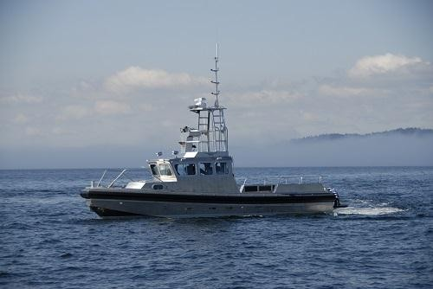
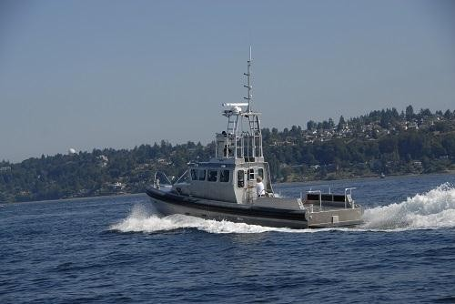

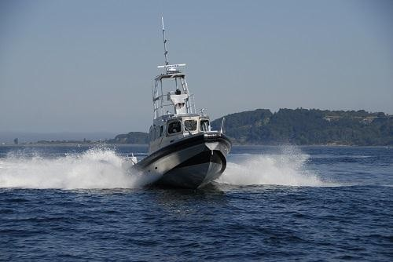
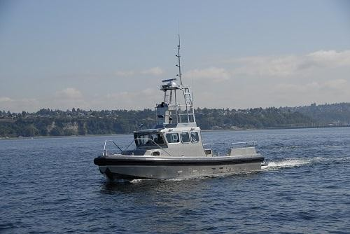
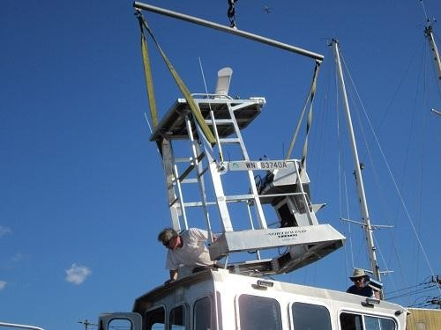
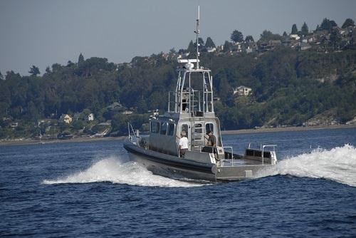

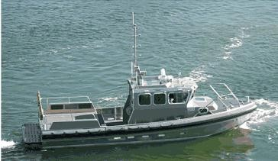
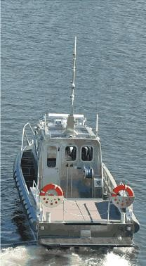
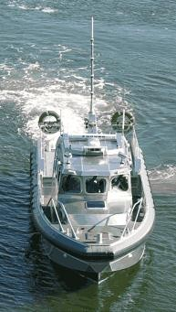

Appendix B -General Drawings of the boat

ך